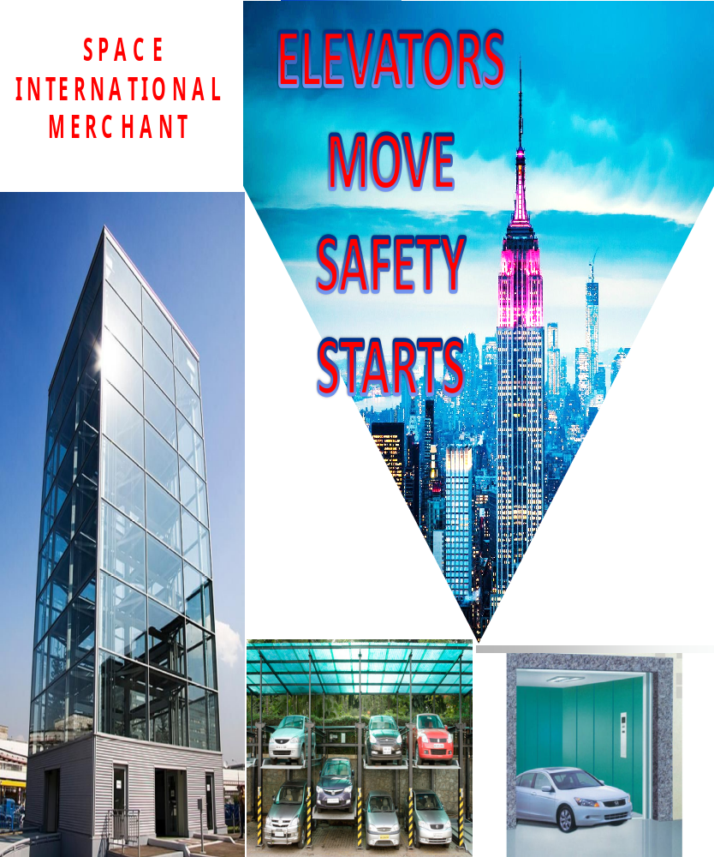

SPACE INTERNATIONAL MERCHANT MAJOR VALUABLE CUSTOMERS
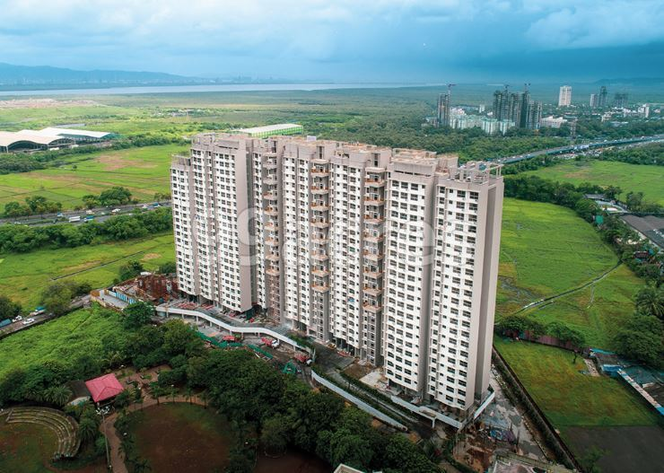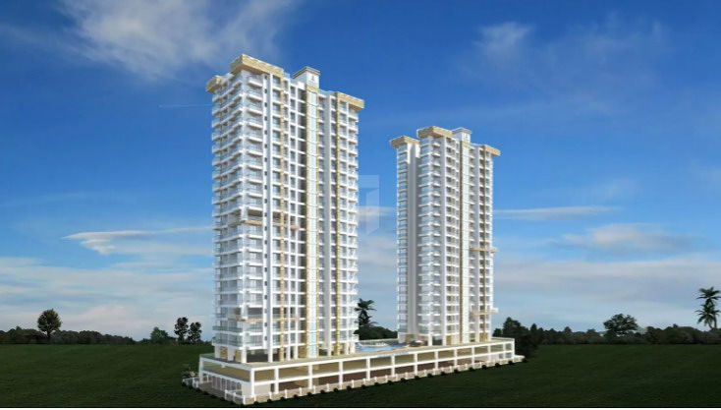 AADI ALLURE CHS KANJURMARG G+23 155 NEMINATH- ANDHERI VERSOVA PRABHAT CHS KLAUS STACK PARKING NKS -100 NOS STACK PARKING

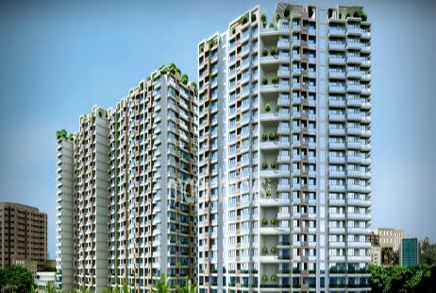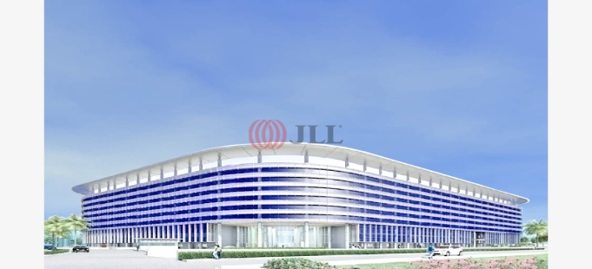
Delta Garden 234 AMC Three level Consultancy - Boomrang Thyssenkrup 25 lifts Stack Parking Mira Road Andheri , Chandiwali
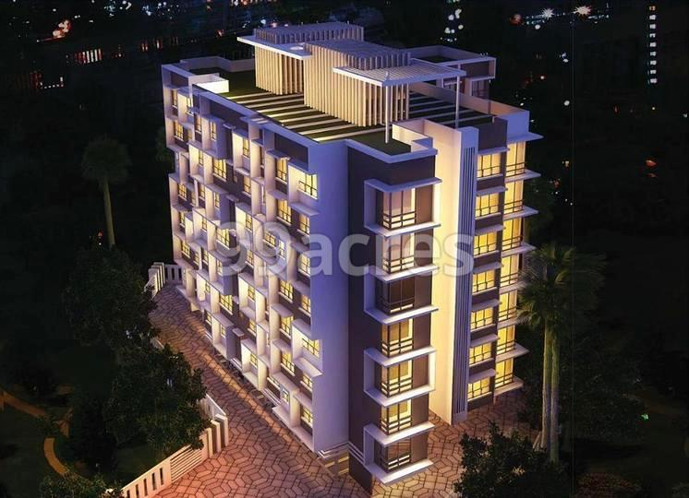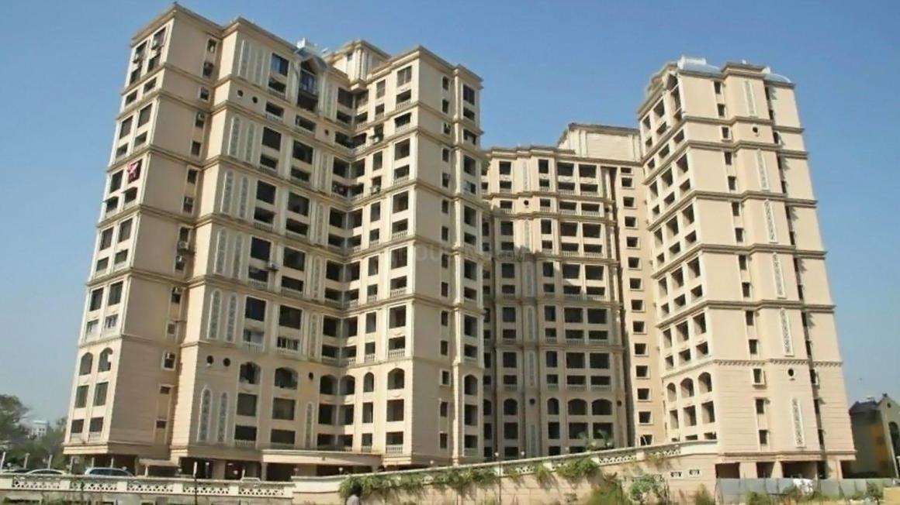
SUBHA ZIRCON ANDHERI PUZZEL PARKING, CANTILIVER GLOFCRAPPE WOHR STACK PARKING CHEMBUR CONTROLLER & SYSTEM AND THREE LEVEL STACK PARKING 60 20 NOS STACK PARKING

SPACE INTERNATIONAL MERCHANT MAJOR VALUABLE CUSTOMERS

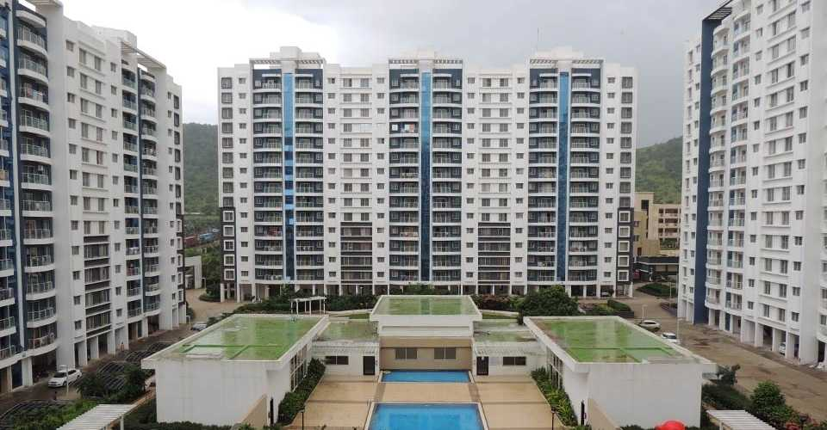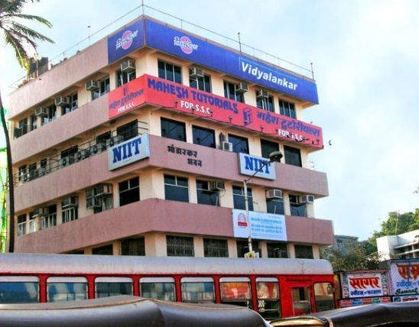
Consultancy- Meghpolis Hyundai 42 lifts Kone Lifts Modernisation with Space Elevators Pune , Hinjewadi
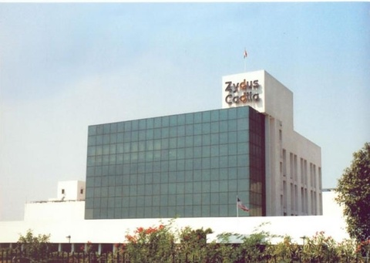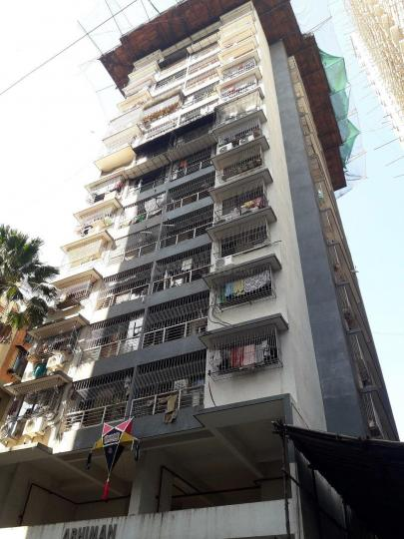
ZYDUS TOWER GOREGAOAN EAST COMMERCIAL Consultancy - Arunodaya chs Elevators EROS
ELEVATORS CAR LIFTS HYDRAULIC AND 2 nos G+18 Goregaon West , Siddharth PASS LIFT 3 LIFTS AND 26 STACK PARKING Nagar`
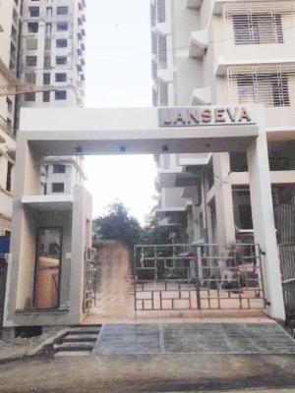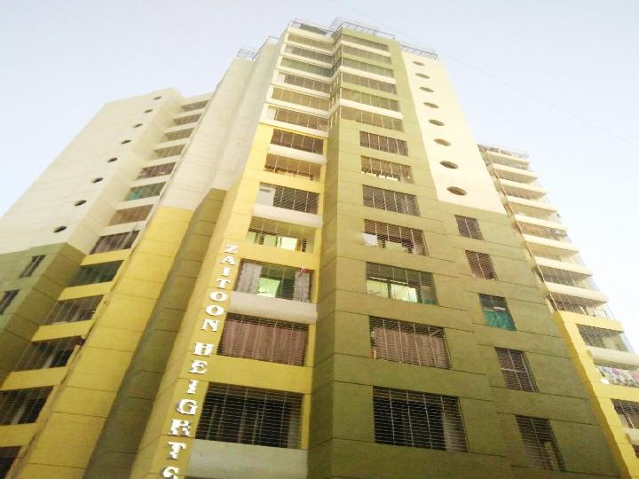
Janseva chs 30 Stack ParKling Single,Double Consultancy - Zaitoon Mira Road G+16 Kone Lift Amc

SPACE INTERNATIONAL MERCHANT MAJOR VALUABLE CUSTOMERS

Laxmi Paradise Mira Road G+10 K B Elevators AMC Prathmesh Height Mira Road G+12 Eskay AMC
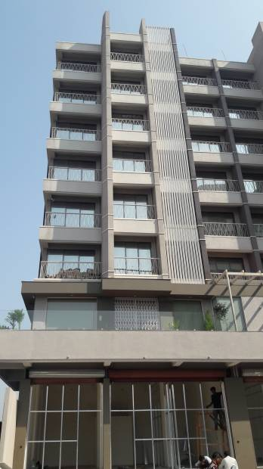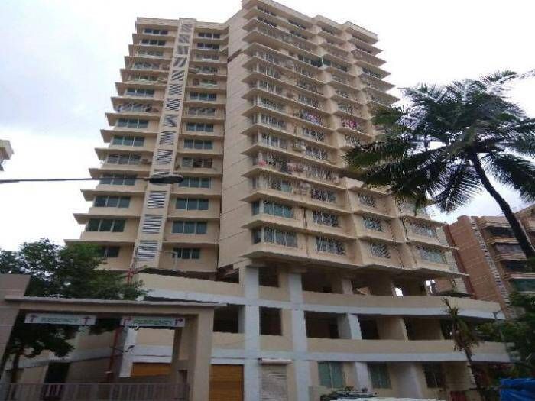
Saroj Arcade Schindler Lifts Soham Residency Boriwali stack parking 50 nos STACK Parking ,2 nos car PARKING, 2 Nnos AMC

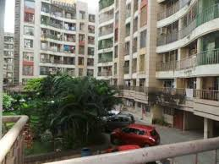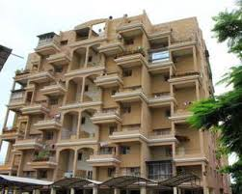
Consultancy - SOLITAIR Mira Road 10 lifts Eskay Consultancy - Ganga Ocean Pune 12 lifts Omega

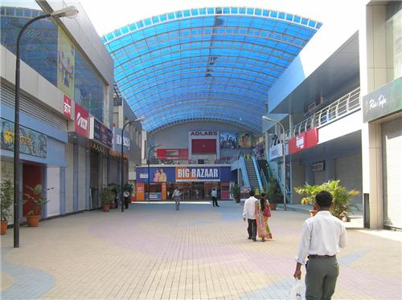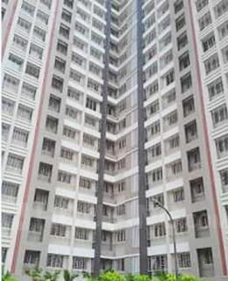
Consultancy - Big Bazar Pune Schindler Lifts Consultancy - Mhada Mira Road G+18 Eskay Eleavtosr

SPACE INTERNATIONAL MERCHANT MAJOR VALUABLE CUSTOMERS

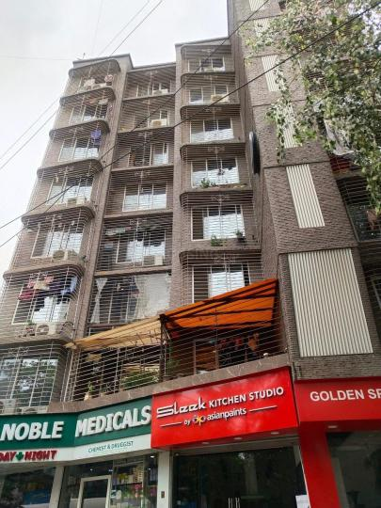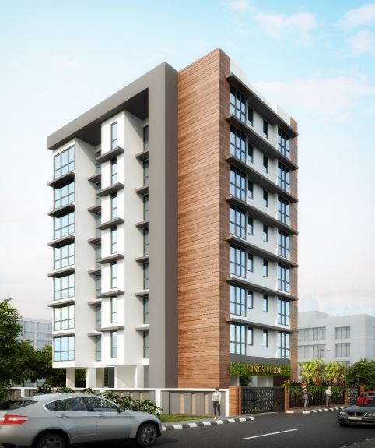
GANGA LAXMI SADAN THREE LEVEL STACK PARKING CHEMBUR , KINGS PRIDE GOVANDI 8 STOP NEW LIFT INSTALLATION
The Prime Minister, Shri Narendra Modi dedicates the ‘Statue of Unity’ to the Nation, on the occasion of the Rashtriya Ekta Diwas, at Kevadiya, in Narmada District of Gujarat, We have installed Air conditioner for Otis elevators.
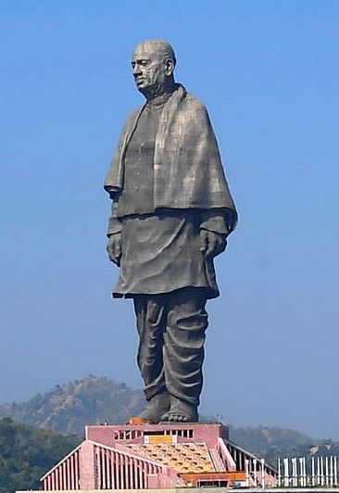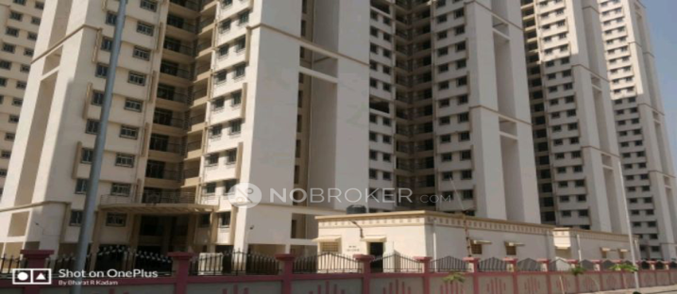
MHADA MIRA ROAD ELEVATOTS FOR 4 LIFTS G+20
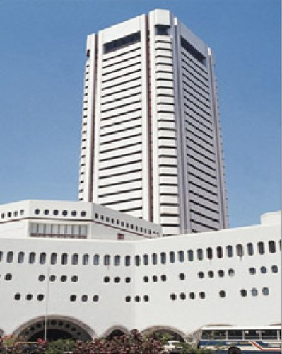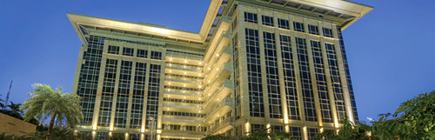
MVIRDC World Trade Centre,Cuff Pared, Mumbai CNERGY IT PARK – ELEVATORS MULTIMEDIA DISPLAYS AND LIVE TV

SPACE INTERNATIONAL MERCHANT MAJOR VALUABLE CUSTOMERS

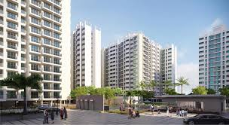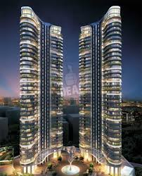
SERENITY AND SAPHIRE MIRA ROAD AMC 12LIFTS WADHAVA GROUP - AQUERIA GRANDE BORIVALI WEST ELEVATORS AC FOR THYSSENKRUP ELEVATORS

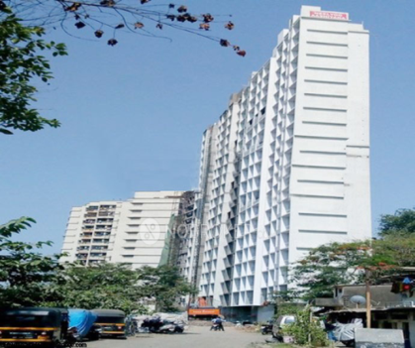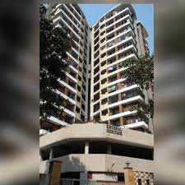
NEELYUG ASHIYANAKANDIWALI WESTDHANUKARWADI KHRISHIVHERITAGE 20 STACK PARKING AMC 15 STACK PARKING
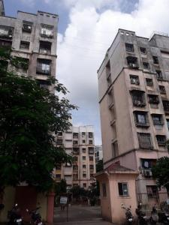
OMKAR PRADHAN STACK PARKING GOREGAON EAST 10 NOS STACK PARKING

SPACE INTERNATIONAL MERCHANT MAJOR VALUABLE CUSTOMERS

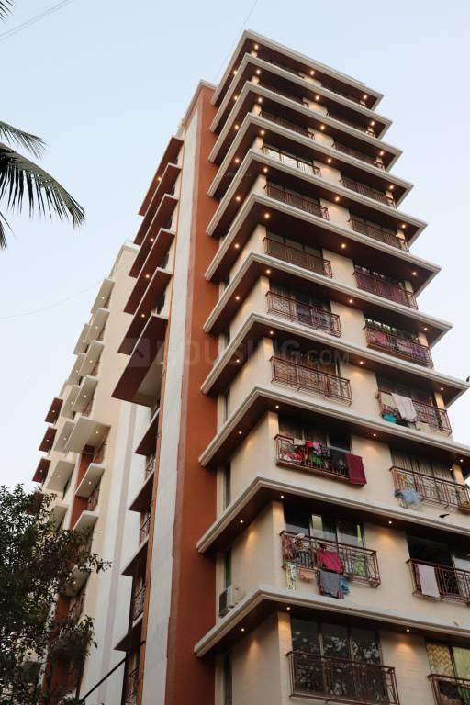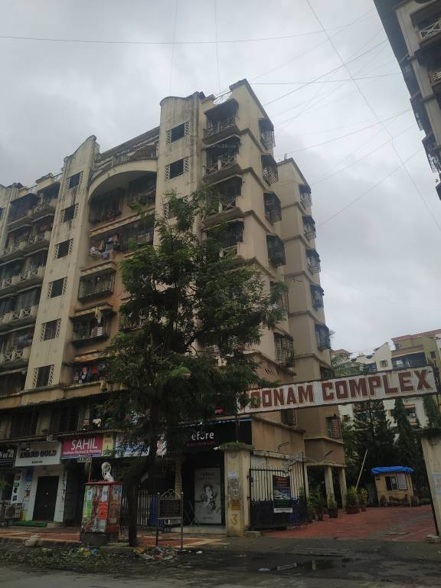
MAYURI HEIGHT JOGESHWARI TWO NUMBER Consultancy - POONAM COMPLEX 5 LIFTS
10 STOPS STACk parking
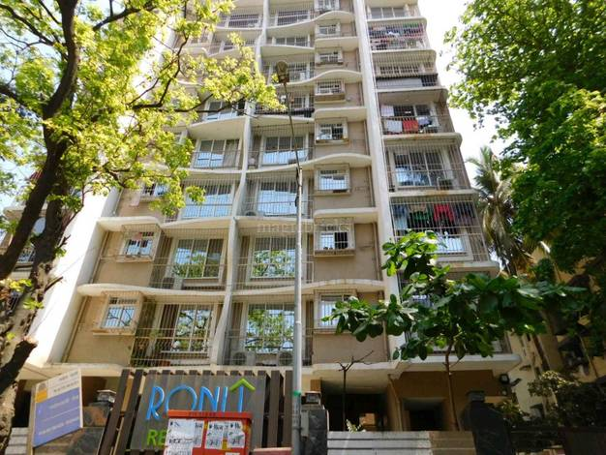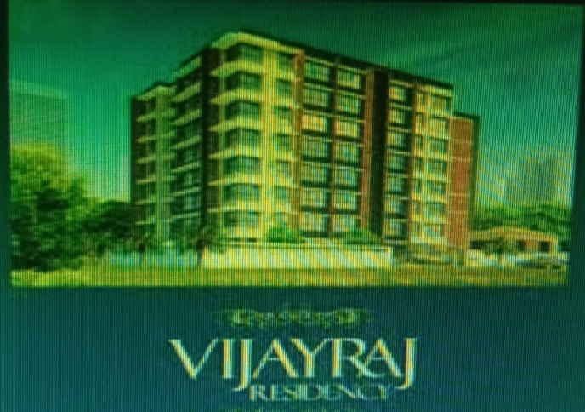
RONIT RESIDENCY STACK APRKING 20 NOS VIJAYRAJ PIT PARKING THREE LEVEL STACK PARKING24 NOS GOREGAON EAST VILEPARLE EAST
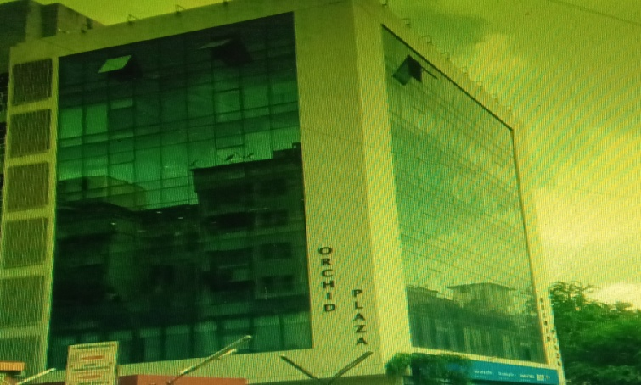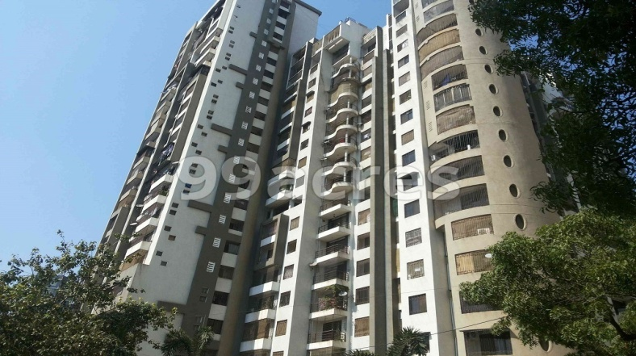
BORIWALI WEST PIT PARKING WOHR THREE LEVEL 45 NOS PARKING BORIWALI IC COLONY ROMELL EMPRESS

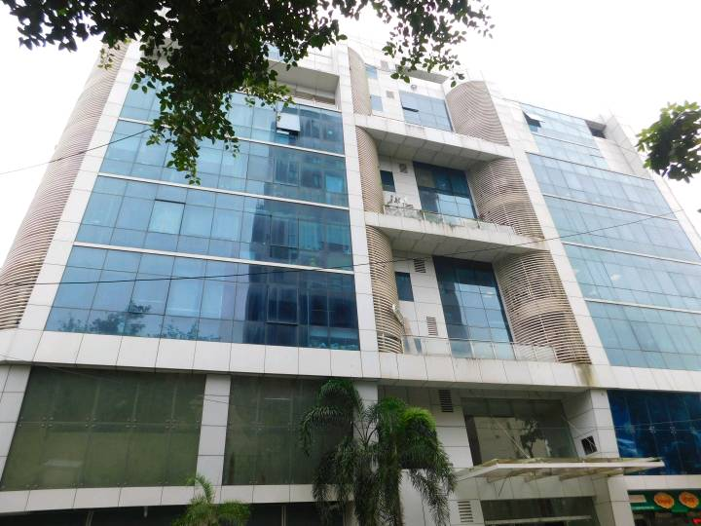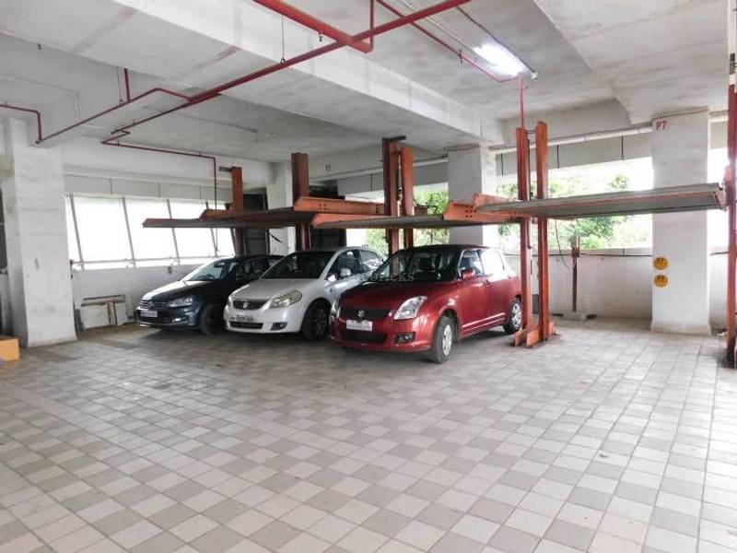
DE ELMASS GOREGAON EAST 35 STACK PARKING IN AMC

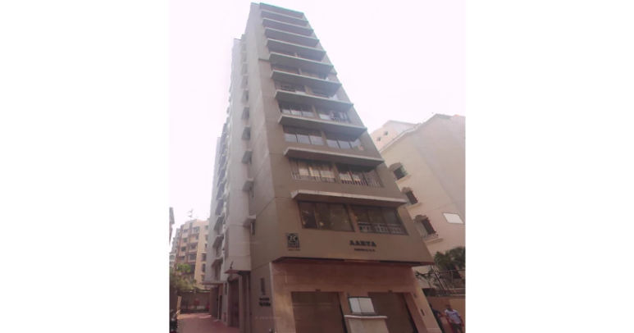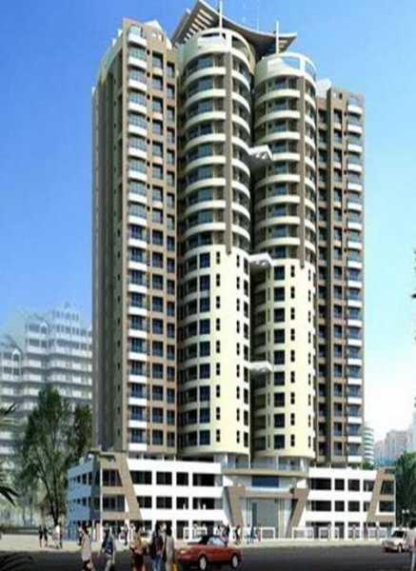
AARYA CHS KHAR 10 NOS STACK PARKING UPGRADATION Consultancy - COSMOPOLITIAN TOWER ANDHERI LOKHANDWALA 21 STORY 4 LIFTS

